Referral to the Community Garden 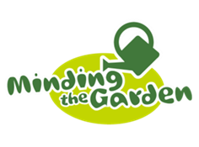
Referrer’s Information
Professional Referral  Yes / No | Family Member Referral  Yes / No | Friend Referral  Yes / No
Full name
Organisation
Telephone number
Email address
Referral date
*By completing this form you are confirming you have had consent to do so by the person you are referring
Details of Person being Referred
Full name
Address
Telephone number
Email address
Date of birth
Gender
Ethnicity
Emergency Contact Details
Full name
Telephone number
Relationship | i.e. friend, family member, support worker
Support and Risk
Does this person have any support needs?
If so, please detail
Does this person pose any risk to others?
If so, please detail
Other Information
Name of GP and Surgery
Why is the person interested in getting involved in the community garden, what activity would they like to do and what do they hope to get out of it?
*Please note we are not able to accept referrals for individuals still in active addiction
*All information provided on this form will be kept securely within Minding the Garden and will not be passed on to any third party without permission, unless there is a concern for the safety of the person or someone that they know (please see HVA’s privacy notice for further information).

