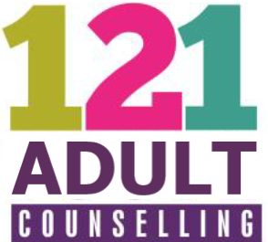
Client ref no (office use only) ……………………………
121 Adult Counselling
Managed by: Hart Voluntary Action
Civic Offices
Harlington Way
Fleet
Hampshire
GU51 4AE

Referral Form

Please complete the form below and either email to 121@hartvolaction.org.uk or post to the address above marked Confidential FAO Counselling Services Manager. If you would prefer to talk to someone then please call 01252 815652 and we can complete the form for you.

Date of referral:

Details:

Name:
Date of Birth:
Gender:
Ethnic Identity:
Address:
Mobile Number:
Email Address:

Referrer Details (if person is not referring themselves):

Name of Referrer:
Email Address of Referrer:
Mobile Number of Referrer:

Emergency contact details:

Name:
Relationship to you:
Phone Number:
Email address:

Where did you hear about 121 Adult Counselling?

Details of GP:

GP Name:
GP Address:
Is the GP aware of this referral? | Yes/No (please delete as appropriate)

Method of Delivery: (We offer Counselling from Odiham Cottage Hospital and online using Zoom or by phone)

Which of these types of session would you be comfortable with (you can choose more than one): | Face-to-face/Zoom/Phone (please delete as appropriate)

Availability: (We offer Counselling on Weekdays either during the day or in the evening)

Please detail here the days you would be available and if you prefer daytime or evening:

Previous experience of Counselling:

Have you had any previous experience of Counselling? | Yes/No (please delete as appropriate)
 | if yes please give details:

Reason for referral:

Presenting Issues (please provide us with a brief outline of why you would like to receive Counselling):
Version 1.0

