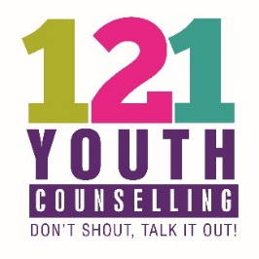

Information for Young People

What do 121 Youth Counselling Offer?

121 Youth Counselling offers up to 20 sessions of face-to-face Counselling for young people aged 11 – 25. This is provided free of charge.

Sessions are available on a weekly basis for 50 weeks of the year. Your sessions will be at the same time and place each week and always with the same Counsellor. Although this is a free service it does cost 121 Youth Counselling up to £40.00 to provide each session. If a young person is unable to attend a Counselling session please provide us with as much notice as possible and, ideally, contact us no later than 24 hours before the start of the session.

What do I do if I am unable to attend?

To notify us of a cancellation please call 01252 815652 or email 121@hartvolaction.org.uk. If 3 sessions are missed without any notification then the appointment space will be given to another young person.

Will you tell anyone what I say?

Counselling is a confidential service which provides a space for you to talk without fear of judgement. The only reason that confidentiality agreement may need to be broken is if the Counsellor feels that you or another person is at risk of harm.

I’m not sure what to expect from Counselling?

Counselling provides a space for you to talk about whatever you need to with a Counsellor who is there to listen to you. It is normal to feel nervous before your sessions. Hopefully once you have met your Counsellor these nerves will decrease.

Sometimes after Counselling you can feel very emotional or tired. This is normal as you will be discussing things that may be difficult for you to talk about. However, over the course of your Counselling sessions you may find that it gets easier.

A Counsellor is not there to give you advice.

What Support is Available for me before my Counselling starts?

Below is a list of different websites you can access to help while you are waiting for Counselling. They may also be useful to use between sessions or after your Counselling has finished.

https://www.giveusashout.org/get-help/ (Text service)
https://www.themix.org.uk/mental-health (Phone line, online and social media help)
https://www.kooth.com/ (Online Counselling)
https://papyrus-uk.org/ (Help in crisis)
https://www.meetwo.co.uk/ (Online chat room to talk to others who have similar problems)
https://youngminds.org.uk/resources/ (Help and advice)
https://www.childline.org.uk/ (Online and phone help)
https://www.headspace.com/headspace-meditation-app (Meditation app for help with relaxation)

Any questions?

If you have any questions regarding 121 Youth Counselling then please contact us by phone on 01252 815652 or email 121@hartvolaction.org.uk.

